|  |
| --- |
| **Nervous System -** Practice Examination Questions |

**Multiple-Choice Section (15 marks)**

Suggested working time is 15 minutes

_________________________________________________________________________

1. The function of the myelin sheath is to

(a) allow the nerve impulse to travel down the entire length of the neuron.

(b) allow the nerve impulse to cross the synapse.

(c) ensure the nerve impulse only travels in one direction.

(d) increase the speed at which a nerve impulse travels.

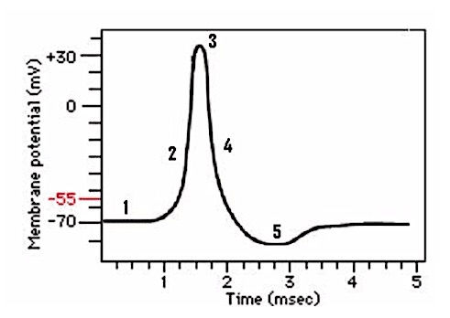**Questions 2 refers to the diagram below.**

2. At which point on the graph is the neuron at rest?

(a) 1

(b) 3

(c) 4

(d) 5

3. Damage to the corpus callosum would cause

(a) lack of coordination between the left and right hemispheres

(b) lack of balance, coordination and fine motor skills.

(c) an increase in the rate of contraction of respiratory muscles.

(d) an increase in the production of hormones.

5. The structure just above the point where the spinal cord enters the skull and is responsible for regulating autonomic responses would be the

1. hypothalamus.
2. cerebrum.
3. cerebellum.
4. medulla oblongata

4. The difference between white and grey matter within the brain is

* 1. the white matter is on the outside away from the nerve tracts, whilst the grey matter is on the inside.
  2. the grey matter contains the unmyelinated nerve fibres and the white matter contains the cell bodies.
  3. the white matter contains the dendrites of neurons, the grey matter contains the nerve fibres.
  4. 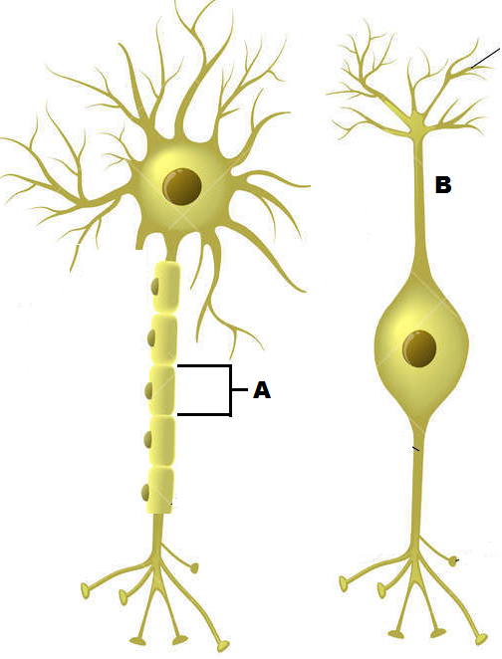the grey matter contains the cell bodies of neurons and the white matter contains the myelinated nerve fibres.

**Question 6 refers to the diagram to the right**

6. The cell labelled A has the following function.

1. Forms the myelin sheath.
2. Provides a conducting surface.
3. Secretes neurotransmitters.
4. Speeds up hormonal impulses.
5. During depolarisation of a neuron membrane

* 1. sodium gates open and sodium ions move into the cell.
  2. potassium ions are pumped into the neuron from surrounding fluid.
  3. large protein molecules move through the membrane cell.
  4. the action potential “jumps” down the neuron from node to node.

8. A threshold stimulus is

1. the stimulus that returns a neuron’s membrane to its resting membrane potential.
2. measured by the difference between the resting membrane potential and zero.
3. represented by the maximum change in potential during depolarisation.
4. the minimum change in potential that will generate a nerve impulse.

9. Which of the following is true about synapses?

* 1. Neurotransmitters bind to receptors on both the post- and pre-synaptic knobs, causing ion-specific channels to open.
  2. Only excitatory signals can be sent across synapses.
  3. Neurotransmitter receptors at the synapse are coupled to ion-specific channels.
  4. A neuromuscular junction is the synapse between a nerve and a gland.

10. Which of the following does **not** describe a feature of the hypothalamus?

1. Regulates body temperature and water intake
2. Produces hormones for both the anterior and posterior pituitary
3. Uses nerve fibres to send chemicals to the posterior pituitary
4. Regulates the autonomic nervous system

**Questions 11 and 12 refer to the diagram presented below**

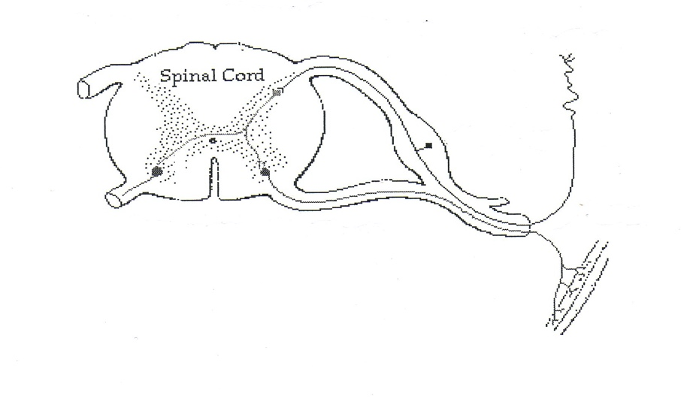

D

C

B

A

11. Which of the following correctly identifies the structures labelled A, B and C?

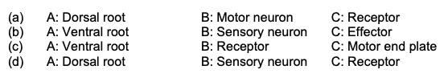

12. If a nerve blockage is applied at point D, a person will be

(a) unable to feel a stimulus but will still be able to respond in a reflex manner.

(b) able to feel a stimulus but will not be able to respond with appropriate movement.

(c) unaffected in terms of reflex action.

(d) able to exert conscious control over movement but reflex action is not possible.

13. The sympathetic nervous system is involved in:

1. Decreasing the heart rate and constriction of the blood vessels in the skin
2. Stimulating motility of the gut and decreasing heart rate
3. Dilation of the bronchioles and decreasing intestinal movement
4. Constricting the pupil of the eye and increasing the heart rate

14. Nervous impulses are carried to the central nervous system by:

1. Effector neurons
2. Interneurons
3. Motor neurons
4. Afferent neurons

**Question 15 refers to the diagram below. It shows a cross-section of the skull and brain**.

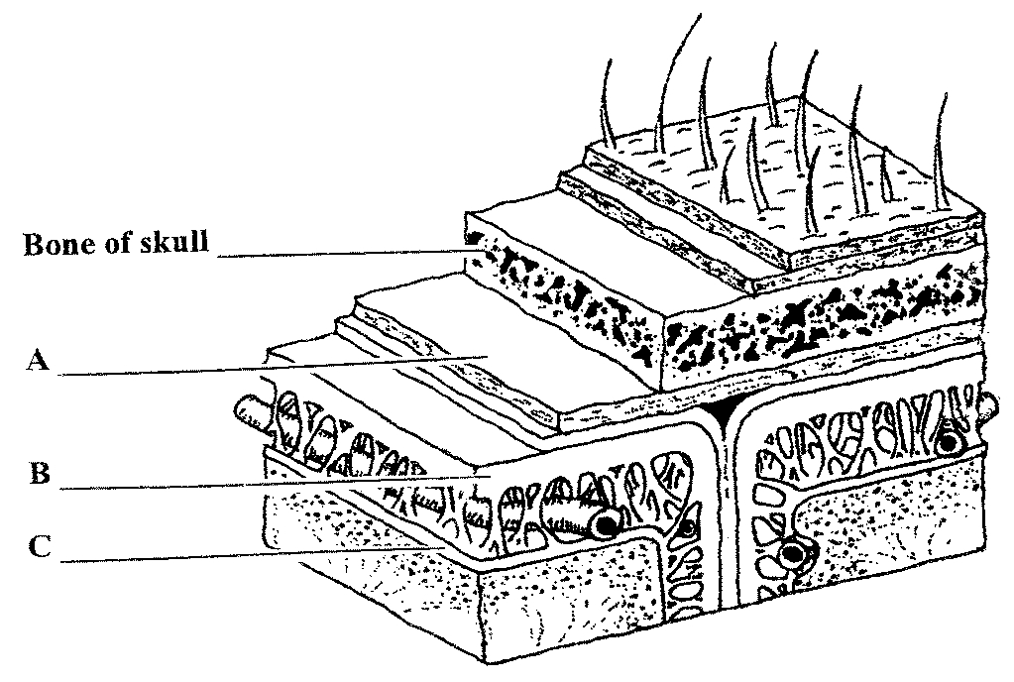

15. The structure labelled B refers to

1. Dura mater
2. Arachnoid
3. Pia mater
4. Cerebrospinal fluid

**Short Answer Section (38 marks)**

Suggested working time is 40 minutes

_________________________________________________________________________

**Question 16 (4 marks)**

The transmission of nerve impulses occurs via electro-chemical changes that occur where the impulse is propagated and transferred.

1. Some anticonvulsants, such as Valium (diazepam), work by allowing more chloride ions to enter a patient’s neurons, making the resting potential more negative. Explain how this would affect the ability of the neuron to generate an action potential. (2 marks)

|  |  |
| --- | --- |
| **Description** | **Marks** |
|  | |
| Lowering the resting potential requires a **stronger stimuli** | 1 |
| to reach the **threshold** and trigger an **impulse/action potential** | 1 |
| **Total** | 2 |

1. During nervous transmission the stimulated neuron enters the refractory period. Explain what is meant by this and describe its purpose.

(2 marks)

|  |  |
| --- | --- |
| **Description** | **Marks** |
|  | |
| Period of time when a **new action potential cannot be triggered** | 1 |
| Allows **ions to return to resting state**/ prevents nerve impulse travelling backwards | 1 |
| **Total** | 2 |

**Question 17 (10 marks)**

The nervous system is composed of two main divisions – the Central Nervous System (CNS) and Peripheral Nervous System (PNS).

1. The CNS contains both grey and white matter. Name the part of the brain which connects the two hemispheres, and describe the type of matter from which it is made. (3 marks)

|  |  |
| --- | --- |
| **Description** | **Marks** |
|  | |
| Corpus Callosum | 1 |
| White matter | 1 |
| Made of myelinated fibres | 1 |
| **Total** | 3 |

1. Due to the delicate and vital nature of the brain and spinal cord, these parts of the body are heavily protected by various structures. Name **one (1)** of the structures and explain how it protects the CNS. (2 marks)

|  |  |
| --- | --- |
| **Description** | **Marks** |
| ANY OF THE FOLLOWING | |
| Bone/Cranium (1) – houses the brain and is rigid/strong (1) |  |
| Meninges (1) –acts as a cushion / softens impact (1) |  |
| Cerebrospinal Fluid (CSF) (1) acts as shock absorber / lessens impact / supports brain (1) |  |
| **Total** | 2 |

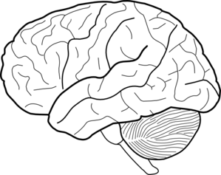

B

A

1. Referring to the diagram above, briefly explain how parts A and B work together to enable a skier to glide smoothly across the snow. (3 marks)

|  |  |
| --- | --- |
| **Description** | **Marks** |
|  | |
| Cerebrum:   * Sensory area receives and processes information from the senses * Initiate voluntary muscle movement, send motor impulse to muscles * Involved in judgement, memory, reasoning to assist with remembering the movements and making decisions | 2 |
| Cerebellum:   * Ensures fine coordination, posture and balance of muscle movement | 1 |
| **Total** | 3 |

1. The efferent division of the peripheral nervous system is divided into autonomic and somatic divisions. Compare two (2) characteristics of the autonomic and somatic nervous divisions of the peripheral nervous system. (2 marks)

ANY 2:

|  |  |
| --- | --- |
| Autonomic | Somatic |
| Involuntary | Voluntary |
| Acetylcholine or noradrenaline neurotransmitter | Acetylcholine only |
| Involuntary muscles and glands are effectors | Skeletal muscles are effectors |
| Two nerves from CNS | One nerve from CNS |
| Pathway contains ganglion | Pathway does not contain ganglion |

**Question 18 (7 marks)**

Use the diagram below to complete the following questions.

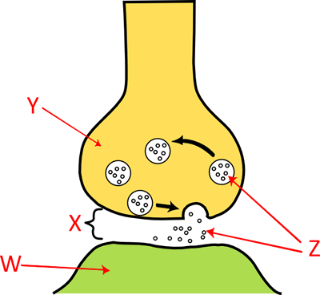

The above diagram is a representation of the way in which a nerve impulse travels across a synapse. (3 marks)

1. Label the following parts of the diagram:

Y Axon terminal/pre-synaptic neuron (NOT JUST AXON)

Z Neurotransmitters

W Post-synaptic neuron/membrane/ dendrite

1. Describe how the nervous information travels from structure Y to structure W and initiates a response. (4 marks)

|  |  |
| --- | --- |
| **Description** | **Marks** |
|  | |
| **Action potential** reaches the axon terminal | 1 |
| Triggers release of **neurotransmitter** from the **vesicles** by **exocytosis** | 1 |
| Neurotransmitter **diffuses** across **synapse**, binds to **receptors** on **post-synaptic membrane** | 1 |
| Triggers **Na+ channels to open** causing **action potential** | 1 |
| **Total** | 4 |

**Question 18 (12 marks)**

A series of action potentials are used to transmit a message along a nerve fibre. A graph of this is shown below.

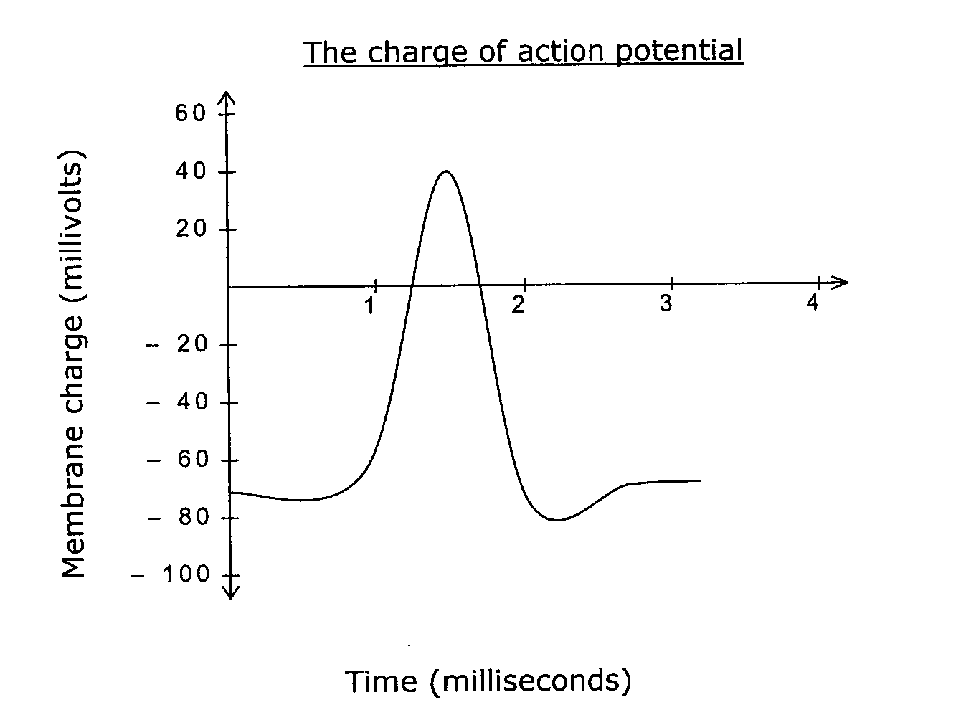

(a) Define the term “action potential”. (2 marks)

Rapid depolarisation (1) and Repolarisation (1) of the Axon Cell Membrane

(b) Mark an **X** on the above graph, the point at which the depolarisation of the nerve impulse commences? (1 mark)

-55mV

(c) Describe the process maintains the resting membrane potential? (2 marks)

Sodium Potassium Pump

Actively transporting 3 Sodium out and 2 Potassium into the Cell

(d) Describe the process causes the axon membrane to depolarise? (3 marks)

Stimulus causes Sodium channels to open

Sodium rushes into the cell: inside of cell becomes increasingly positive.

(e) Compare and contrast the passage of a nerve impulse along a myelinated and unmyelinated neuron. (4 marks)

Myelinated: Myelin is an insulator.

Action Potential can only occur at the nodes of Ranvier (gaps in the myelin)

Impulse jumps from Node to Node (Saltatory Conduction). Therefore much more rapid

Unmyelinated: much slower as the impulse must travel down the whole cell.

**Question 19 (5 marks)**

The diagram below shows a cross section of the human brain.

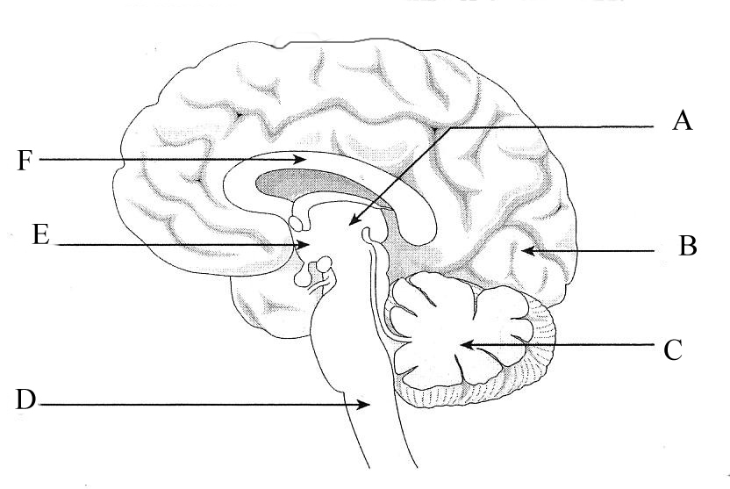

(a) Label the following parts: (2 marks)

E Hypothalamus

B Cerebrum

(c) Structure D is surrounded by membranes called meninges, which are filled with fluid. Identify the name of this fluid and describe TWO functions of the fluid. (3 marks)

Cerebrospinal Fluid

Any two:

Shock absorbing

Protection

Provide Nutrients to the brain and Spinal Cord

**Extended Response (20 marks)**

Suggested working time is 20 minutes

_________________________________________________________________________

**Question 20**

During a cooking lesson, a student accidently touches a hot tray in the oven. She notices that she has removed her hand from the hot tray without giving it any thought.

Describe, making reference to specific structures, the mechanism that would protect her from serious injury and explain why only later she realised what had happened. (10 marks)

Pain stimulus is detected by a receptor (1)

Which causes a nerve impulse to travel up the sensory neuron (1)

To the cell body in the dorsal root ganglion (1)

Then on to synapse with a connector / association neuron (1)

in the grey matter of the spinal cord (inter neuron unmyelinated) (1)

Which synapses with a motor neuron (1)

The nerve impulse travels down the axon of the motor neuron via ventral root (1)

To the effectors which are the skeletal muscles, that contract and remove the body

part from the stimulus (1)

At the same time the connector neuron sends a nerve impulse to a sensory neuron, which travels up an ascending tract of the spinal cord (1)

to the cerebrum of the brain, so that awareness / sensation is achieved after the action to remove the part has occurred (1)

**Question 21**

The Nervous System is divided into a number of important divisions. Discuss the organisation and functions of the Central and Peripheral Nervous Systems.

(10 marks)

CNS: Brain and Spinal cord 1

Interprets sensory information, initiates motor movements, homeostasis, association, grey and white matter arrangement etc… 2

PNS: 12 Cranial and 31 spinal Nerves branching off CNS 1

Afferent: Sensory neurons: carry information towards CNS 1

Efferent: Motor neurons: carry information away from CNS 1

Somatic: Voluntary: Skeletal muscle effector 1

Autonomic: involuntary: smooth muscles/glands as effectors 1

Sympathetic: fight or flight response: noradrenaline: explain with examples 1

Parasympathetic: acetylcholine: times of rest: explain with examples 1